Ideation Phase
Define the Problem Statements

Date | 11 October 2026
Team ID | SWUID2026399565
Project Name | IMovies – Movie Ticket Booking Made Simple
Maximum Marks | 2 Marks
Customer Problem Statement Template:
To define the core problems moviegoers face while booking cinema tickets online, and use those insights to guide the development of IMovies – a simple, fast and transparent movie ticket booking platform.
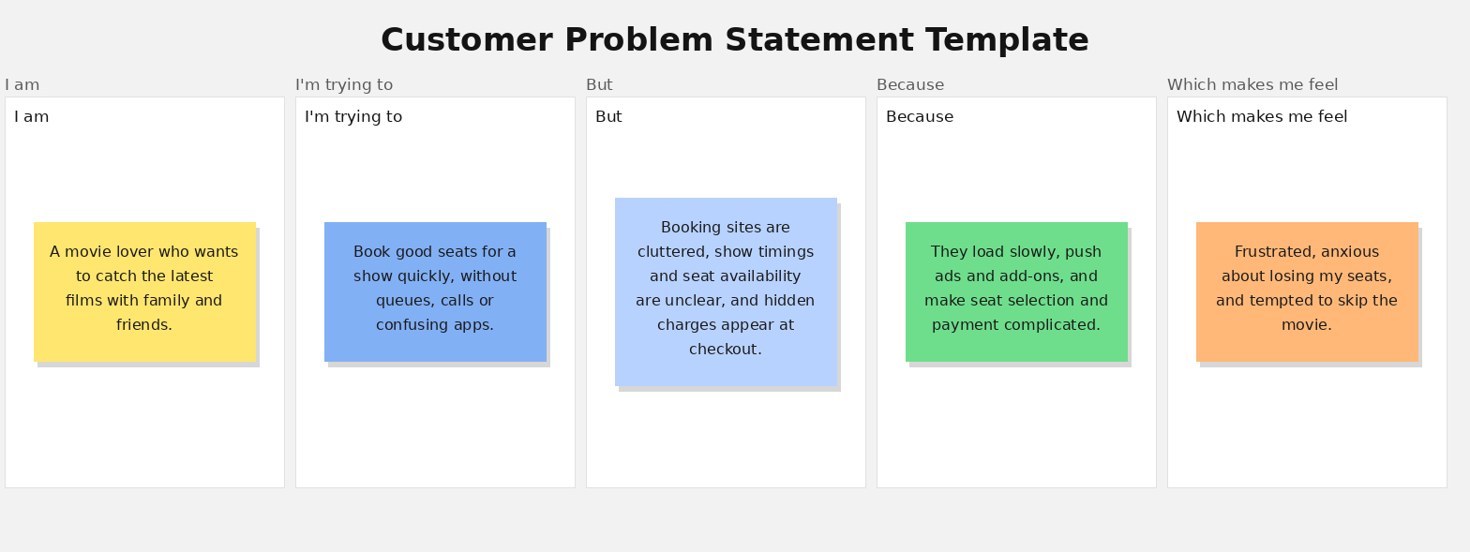
Reference: https://miro.com/templates/customer-problem-statement/
Problem Statement (PS) | I am (Customer) | I'm trying to | But | Because | Which makes me feel
PS-1 | a working professional who loves movies | book tickets for a new release quickly after a long day | the app is slow and show timings and seat availability are hard to find | the interface is cluttered and shows too many ads and pop-ups | frustrated and tempted to give up on the plan.
PS-2 | a student on a tight budget | find the cheapest ticket price for a show | extra convenience fees and taxes only appear at the final payment step | pricing is not shown clearly during selection | cheated and unsure whether to trust the platform.
PS-3 | a parent planning a family outing | choose seats together for 4 people in a good section | the seat map is confusing and seats get taken while I am selecting | the seat lock and availability update are not clear or reliable | anxious and stressed about losing my seats.
PS-4 | a regular moviegoer | pay online and receive my ticket instantly | payments fail or get stuck and the refund is slow or unclear | the payment flow is complicated and gives little status feedback | worried about my money and annoyed at wasted time.
PS-5 | a first-time or senior user | book a movie ticket without help from others | the steps are too many and the app is hard to understand | it assumes users are comfortable with technology and offers little guidance | confused and dependent on others.

